**DESIGN UI FOR OUT CHATBOT**

**CREATE ACCOUNT**

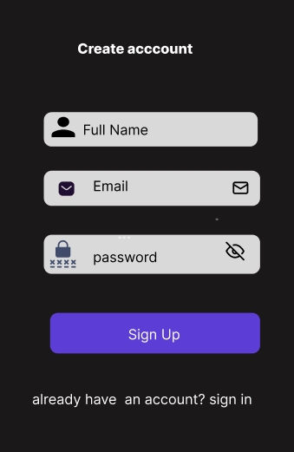

**LOG IN**

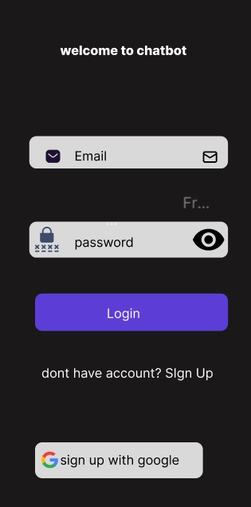

**INTRO PAGE**

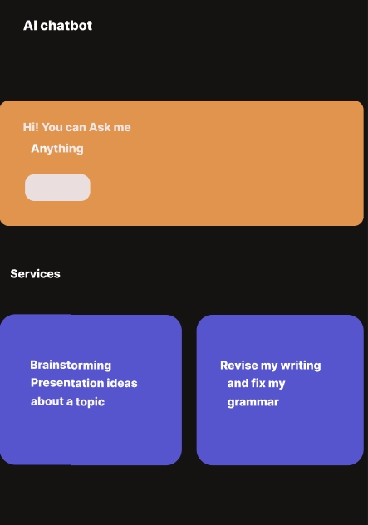

**MAIN PAGE**

